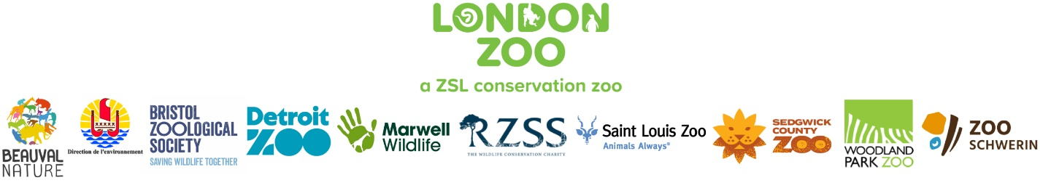

PRESS RELEASE: EMBARGOED UNTIL THURSDAY 26 SEPTEMBER 2024, 00:01am BST
Media Contact: Alex Kemsley, Senior Press Officer, London Zoo alex.kemsley@zsl.org
Interviews available with Paul Pearce-Kelly on request

Over 6,000 ‘extinct’ snails return to the wild, with a re-established wild species now confirmed
Snail mail: Collaboration between zoos sees largest release of Extinct-in-the-Wild Partula snails in history

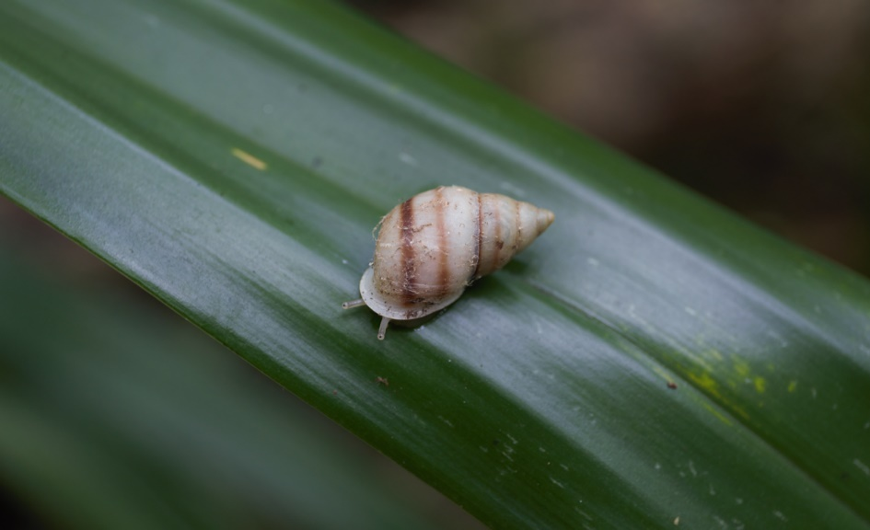
The discovery of unmarked Partula tohiveana snails marks the re-establishment of an Extinct-in-the-Wild species
(c) Paul Pearce-Kelly / London Zoo

A global conservation effort to reintroduce a tiny snail to the wild is celebrating a momentous milestone, as for the first time in 40 years, conservationists have found born-in-the-wild adult Partula tohiveana – meaning the precious molluscs have successfully established themselves in French Polynesia.
During the annual reintroduction of the zoo-bred Extinct in the Wild and Critically Endangered snails to their French Polynesian island home – which this year saw zoos around the world restore over 6,000 snails to Moorea – the team, led by ZSL’s Senior Curator of Invertebrates & Fish and Partula project coordinator, Paul Pearce-Kelly, found unmarked Partula tohiveana: proof that previously reintroduced snails have successfully bred in the area.
The momentous discovery means Partula tohiveana can now be considered as established – an incredibly rewarding result for 40 years of dedication and collaboration. Conservationists will now begin the process of downlisting the snails from Extinct-in-the-Wild to Critically Endangered on the IUCN’s Red List.
Ten species and sub-species of the tropical snails, reared at London Zoo, Bristol Zoological Society, Detroit Zoological Society, Marwell Wildlife, the Royal Zoological Society of Scotland, Saint Louis Zoo, Sedgwick County Zoo, Woodland Park Zoo and Zoo Schwerin, travelled more than 15,000km to Tahiti at the beginning of September. Before making the two-day journey to the islands of Tahiti, Moorea and Huahine, the incredibly rare snails, which each measure a tiny 1-2cm in length, were individually counted and marked with a dot of UV reflective paint. The ‘snail varnish’ glows under UV torchlight, helping conservationists in the field to spot and monitor the nocturnal snails at night, when they’re most active.
London Zoo’s Senior Curator of Invertebrates, Paul Pearce-Kelly, who leads the Partula conservation programme, said: “Though little these snails have great cultural, scientific and conservation value. Partula snails have always been part of Polynesia’s rich cultural heritage and play an important role in the ecological health of their forest habitats. They’ve also been studied for over a century for the insights they give into how species evolve in isolated environments. Most recently, they’re providing a valuable conservation model for helping hundreds of endangered island species.”
“This collaborative conservation effort is playing a crucial role in saving these species from extinction. It’s a powerful example of how conservation zoos can combat biodiversity loss. At a time when nature faces unprecedented challenges, these small snails are a symbol of hope for global wildlife.”
Partula snails - also known as Polynesian tree snails - eat decaying plant tissue and fungi, so play an important role in maintaining forest health. Returning these rare snails back to the wild helps to restore the ecological balance in these islands.
Conservation zoos are working with the French Polynesian Government’s Direction de l’environnement, to save Partula snails from extinction. In the 1980s and early 1990s, these snails faced a critical threat after the invasive rosy wolf snail (Euglandina rosea) was introduced to control the African giant land snail (Lissachatina fulica). Unfortunately, the predatory species targeted the native snails instead, leading to the extinction or near-extinction of many Partula species across the region.
In the early 1990s, the last remaining individuals of several Partula species were rescued by London and Edinburgh Zoos, launching an international conservation breeding programme. This collaboration between 15 zoos cares for 15 species and subspecies, most of which are classified as Extinct-in-the-Wild. These rescued snails, along with those already being studied at universities in the UK and North America, became the foundation for reintroducing the species back onto their native island homes.
Paul said: “After decades of caring for these species in conservation zoos and working with the Direction de l’environnement to prepare the islands, we started reintroducing Partula snails back into their lowland tropical forests almost 10 years ago. Since then, we’ve reintroduced over 30,000 snails, including 10 Extinct-in-the-Wild species and subspecies, with this year’s release being the largest so far, thanks to our international team and collaborators, including mollusc specialist Dr. Justin Gerlach of Peterhouse, University of Cambridge.”
Baptiste Mulot, Beauval Nature's Executive Director, said: “Beauval Nature is proud to support the reintroduction of Partula snails. Among 70 projects, Beauval Nature is very careful about small species as snails and amphibians. It's an exciting, ambitious and hopeful project in which we hope to become even more involved in the coming years.”
Kerry Marcus, Bristol Zoological Society’s Senior Ectotherm Keeper, said: “As a conservation and education charity working in nine countries across four continents, Bristol Zoological Society is very proud to be involved in this breeding project. It’s fantastic to be a part of such a vital conservation collaboration and to witness the positive impact the return of this important species has to a fragile forest ecosystem that relies on their survival. Partula snails play an important role in maintaining tropical tree health in French Polynesia by recycling nutrients from plant debris. Since the project started back in 1986, over 21,000 individuals of 11 previously Extinct-in-the-Wild species of Partula snails have been reintroduced into the wild on four different islands in French Polynesia.”
Christophe Brocherieux, Environment Department of French Polynesia’s Environment Project Manager, said: “We're really proud to be part of this massive reintroduction project and to be able to contribute to it. The results are really encouraging.”
Mark Vassallo, Detroit Zoological Society’s Curator of Amphibians, said: “The Detroit Zoological Society (DZS) has been a participating in the recovery of the Partula snail since 1989. Since that time, the DZS has contributed 2,740 of these IUCN-listed "extinct in the wild" invertebrates to their native range on the island of Tahiti as part of the partnership of zoos and aquariums working to save this species. The colony of Partula nodosa at the DZS is housed at the Zoo's National Amphibian Conservation Center and receives specialized care from zookeepers who pay particular attention to the needs of this special little snail, providing specific environmental conditions, diet and lighting to ensure these animals the best chance to contribute to the population of snails in the wild. The DZS is proud to work with its program partners to help save this species from extinction and contribute to the recovery of wildlife and wild spaces across the globe.”
Laura Read, Marwell Wildlife’s Chief Executive, said: “We’re delighted to have contributed 1,640 snails to this year’s release. Snails may not be considered as the poster child for wildlife conservation, but they play an incredibly important role in the ecosystem, ensuring natural balance and enriching the environment around them. By pulling species like these back from the brink of extinction we’re able to make a real contribution to the future of our planet and to nature’s recovery. We have been delighted to work with many other partners on this project, including ZSL and it is testament to what can be achieved when we all work together.”
Jo Elliot, Royal Zoological Society of Scotland’s Curator, said: “It is extremely exciting to be able to send over 2,500 of our Partula snails, which we have been breeding at Edinburgh Zoo for 40 years, to be reintroduced directly back into their native habitat. As a wildlife conservation charity, we are proud to be part of this vital collaborative breeding project, which is giving this incredible species a significant boost. Our success within the Partula snail programme is owed to the teams who began the work here at Edinburgh Zoo many years ago and to those who now form the wider project partnership, working to ensure this initiative goes from strength to strength. This is a really wonderful conservation success story and further demonstrates the critical role zoos play in species recovery.”
Kayla Garcia, Saint Louis Zoo’s Zoological Manager of Invertebrates, said: "Saint Louis Zoo has dedicated thousands of staff and volunteer hours over decades to saving this highly endangered snail. We are incredibly proud that all our work and the tireless efforts of our collaborators have made this reintroduction into the wild possible."
Nate Nelson, Sedgwick County Zoo’s Curator of Ectotherms, said: “Since joining the Partula snail program in 2017, the Sedgwick County Zoo has played an active role in this international conservation initiative. We’ve successfully contributed to the reintroduction of Partula snails into the wild in Tahiti, with snails bred right here in Kansas. Our dedicated staff has also travelled to the field, providing hands-on support for this significant effort to restore these endangered species to their native habitats.”
Dr Justin Gerlach of Peterhouse, University of Cambridge, said: “Discovering wild-born adult snails was a great moment. Very few animal species have been re-established back in the wild so this is a fantastic achievement for the programme – the fruit of a vast amount of work.”
Erin Sullivan, Woodland Park Zoo’s Curator, said: “More than 20 years ago, Woodland Park Zoo joined the national and international efforts to breed Partula snails to help this miniscule mollusk recover and restore them to their native habitats. Thanks to the specialized care by our animal keepers and our Tree Snail Lab, we have a special and secure space to focus our work coupled with optimal breeding conditions for the snails. We’re proud to send nearly 500 snails for this introduction.”
Dr. Tim Schikora, Zoo Schwerin’s CEO and Director, said: “Zoo Schwerin's contribution to this project represents a tremendous collaborative achievement, demonstrating how global partnerships can reverse the tide of extinction. It is a proud moment for Zoo Schwerin to see these Partula snails return to their island homes and help restore balance in French Polynesia’s ecosystems.”
London Zoo’s coordination of the Partula snail reintroduction project is made possible due to funding from supporters including the Players of the People’s Postcode Lottery, who have enabled London Zoo to continue bringing species back from the brink of extinction.
To explore the vital conservation work being carried out at London Zoo - a ZSL conservation zoo - head to www.londonzoo.org.
-Ends-

Media contact: Alex Kemsley, Senior Press Officer, London Zoo alex.kemsley@zsl.org

Partula snails (Partulidae family)
The Partula snails represent a genus of tropical land snails, specially adapted to live in different volcanic valleys across the archipelago. The genus contains 104 species, of which there are 15 species and subspecies in the conservation breeding programme. Once abundant across the islands, many species of Partula were nearly wiped out in the 1980s and early 1990s after the rosy wolf snail was introduced to rid the island of a previously-introduced alien species, the African giant land snail (Lissachatina fulica).

Partula species and sub-species involved in this year’s reintroduction are: Partula affinis; Partula hyalina; Partula mirabilis; Partula mooreana; Partula nodosa; Partula suturalis vexillum; Partula taeniata nucleola; Partula taeniata simulans; Partula tohiveana; Partula varia.

ZSL’s Extinct in the Wild Alliance: conservation zoos collaborating to reverse extinction
In 2023, scientists released a study in the journal Science – the world’s leading outlet for cutting edge science – showing that conservation zoos have the powerful potential to reverse species extinction. The paper outlines how immense collaborative efforts by zoos and botanical institutions – working alongside governments and partners responsible for wild habitats – have combined to prevent extinction and allow some species to successfully reclaim their wild habitats.
Working with partners, ZSL have formed an Extinct in the Wild Alliance (EWA) to drive forward species recovery of the world’s most threatened species, and to secure the future for these species and restore them responsibly back into safe wild habitat. We are drawing a line in the sand to halt human induced species extinction.

London Zoo – a ZSL conservation zoo
London Zoo is part of ZSL, a science-driven conservation charity, working to protect and restore wildlife in the UK and around the world. First opened to the public in 1828, London Zoo works to restore wildlife through vital conservation breeding programmes and inspiring a lifelong love of animals in the conservationists of tomorrow. Get closer to nature in one of the world’s most vibrant capital cities. Visit www.londonzoo.org for more information and to book tickets.

ZSL
Founded in 1826, ZSL is an international conservation charity, driven by science, working to restore wildlife in the UK and around the world; by protecting critical species, restoring ecosystems, helping people and wildlife live together and inspiring support for nature. Through our leading conservation zoos, London and Whipsnade, we bring people closer to nature and use our expertise to protect wildlife today, while inspiring a lifelong love of animals in the conservationists of tomorrow. Visit www.zsl.org for more information.

Use of ZSL images and video
Photographs, video or graphics distributed by London Zoo to support this media release may only be used for editorial reporting purposes for the contemporaneous illustration of events, things or the persons in the image or facts mentioned in the media release or image caption. Reuse of the picture or video requires further permission from the press office of London Zoo.

General Data Protection Regulation (GDPR)
You are currently on the Whipsnade Zoo databases as a press contact. We class press contacts as the journalists, press officers and those working within science communications who have helped ensure Whipsnade Zoo can continue its mission to ensure the public have access to the best scientific evidence and expertise through the news media when science hits the headlines. Due to the new General Data Protection Regulation (GDPR), we are letting you know that we hold and process your data under legitimate interest. At any time you can object to the holding or processing of your data, and we will remove you from our database. More information on what we hold, why we keep it and what we use it for is available in our privacy statement. If you have any further questions, please get in touch.

